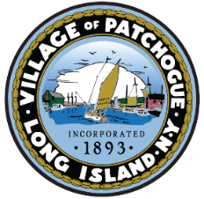
VILLAGE OF PATCHOGUE
VENDOR PERMIT APPLICATION
Great South Bay Music Festival
Thursday, July 20, 2023 – Sunday, July 23, 2023

Dear Vendor:
The Incorporated Village of Patchogue requires ALL Music Festival vendors to obtain a permit from the Office of the Village Clerk. Please complete the application below and return with the appropriate payment. All check payments should be made payable to the Great South Bay Music Festival and mailed to:
Great South Bay Music Festival
P.O. Box 346
Port Jefferson, NY 11777

All nonprofit organizations are exempt from vendor fees however proof of nonprofit status must be submitted with this application.

Name of Business: __________________________________________________

Business Address: ___________________________________________________

____________________________________________________

Phone: ____________________________________________________

Name of Owner: ____________________________________________________

Type of Business
$70 Food/Beverage: ______ $45 Craft Vendor: _____ Nonprofit: _____

PLEASE NOTE THAT ALL VENDOR PERMITS MUST BE PURCHASED NO LATER THAN TUESDAY, JULY 15, 2023. YOU WILL NOT BE PERMITTED TO SET-UP IF YOU DO NOT HAVE A VALID PERMIT.

