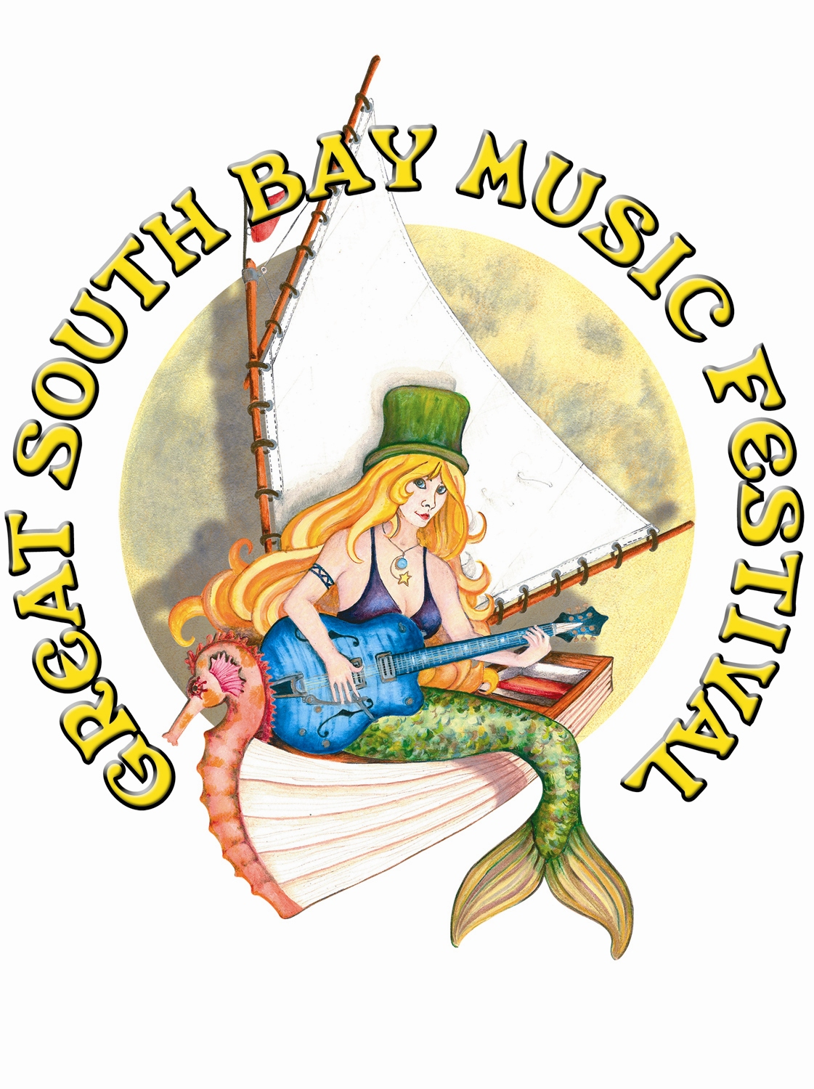
GREAT SOUTH BAY MUSIC FESTIVAL, LLC
NON-PROFIT VENDOR INFORMATION/APPLICATION
(Keep this page)

DATE: July 24, 25, 26, 27, 2025 - Friday, Saturday, Sunday
PLACE: Shorefront Park, Patchogue, NY (Located on the Water Front)

REGISTRATION FEE: No Registration Fee

All Accepted Non-Profit vendors will be placed in our Storyville Community Tent.
***LIMITED AVAILABILITY***
Non-Profits to Follow “Craft Market Vendor” information regarding flow of weekend
______________________________________________________________________________

GENERAL INFORMATION

Booth Size: Non-Profit organizations will be placed under out Storyville Community tent. Please provide a table and chairs. Limit your area to one corner of the tent as many organizations will be together to create a community tent.

Load In Location: Ryder Ave & Smith Street.
Village of Patchogue: Patchogue Village requires that ALL participating Vendors must fill out a “Vendor Permit Application” - Please have permit from the Village of Patchogue on hand at the festival. The Village will be doing permit checks – failure to provide permit will result in closure of your booth.

Electricity: Electricity is included in the vendor fee. Electricity provided is 10amps, which is sufficient for basic lighting. If additional power is needed, vendor will be charged accordingly.

Cancellation: Vendors must give GSBMF no less than four weeks’ notice prior to load in date, of intent to cancel their participation or booth fee will be forfeited.

Check in/Load in: Set up is between 8-11am on FRIDAY
Set up is outdoors on grass/sand, located on the waterfront. The festival is rain or shine. This is an outdoor event; be prepared for any type of weather. Tents, canopies and pop -ups must be secured to withstand strong winds.
You will be allowed to drive your vehicle in the vicinity of the booth area, in some cases, right up to your booth. If you do not set up in the allotted set up times stated above, you may have to walk your tent/merch to your plot as the village will clear the field and block off the roads. Vehicles must be moved to the required parking area immediately following load in.

Security: The GSBMF will provide 24-hour security, though booths and its merchandise are the sole responsibility of the vendor owner. You must lock up all of your merchandise at night as the GSBMF will not be responsible.
Passes: All vendors will receive two vehicle passes (no more), and two wristbands for staff, per 10x10 booth space, per day. Additional Staff wristbands can be purchased for $25 at check-in. Cash only. Parking directions will be given out at check in.
Hours of Operation: Doors are 3 PM on Thursday & Friday (note: vendor market is closed on Thursday, only Main Stage & select corporate vendors will be open). Saturday doors are 1PM. Sunday doors are 12 PM for the children’s show with main doors immediately following at 130 PM.
Other: Bring all of your own display materials: lawn or festival style chairs, tables, refuse cans, lights, extension cords, etc. Vendors are responsible for constructing, furnishing, lighting, maintaining, and removing your own booth materials and especially trash.
Booth acceptance is based on the understanding that you will only sell the merchandise that you have listed on your application. Under no circumstances will any vendor be allowed to sell merchandise that refers to, or imprints "The Great South Bay Music Festival".
No CD's are permitted for sale unless approved in writing by GSBMF
Insurance: Vendors must provide certificate of insurance, naming GSBMF and the Village of Patchogue as additional insureds. Insurance requirements: Workers compensation: Statutory Limits, Employer Liability: $1,000,000, Owned/hired/ or non-owned Auto Liability: $1,000,000, Commercial General Liability: $1,000,000 each occurrence, $2,000,000 General Aggregate and $2,000,000 Products, Completed Operations for bodily injury, property damage and personal injury.

Ice: Will be available for purchase.
Pets: Unfortunately, no pets will be allowed on the festival site except those participating in the show. NO EXCEPTIONS!

Hotels: Hotels just 15 minutes away for all artists, employees, and vendors participating in the festival. Please contact Jamie Faith (Off: 631-331-0808 to coordinate)

GREAT SOUTH BAY MUSIC FESTIVAL, LLC
NON-PROFIT
July 25, 26, & 27 2025
(Return this page)
Name: ______________________________________________________________________________
Booth/Company Name: __________________________________________________________________
Address: _____________________________________________________________________________
City, State, Zip: _______________________________________________________________________
Phone: (_____)_____________________________ Fax: (_____)_______________________________
Email: ______________________________________ Sales Tax or Resale #: ______________________
Website/Facebook: ________________________________

Description of Organization, Cause, And Use For Booth: __________________________________________________________________________________________________________________________________________________________________________________________________________________________________________________________________________________________________________________

- Please attach to your application confirmation of 501 (c) (3) status.
- GSBMF LLC provides a booth space at no fee for Non-Profit Vendors.
- Your organization to provide chairs, tables, display materials, etc.
- Non-profits will be placed under our community “Storyville Tent”

Include your check for the full amount or your application will be refused. You will be notified of approval within 2 weeks. In the event of refusal, all monies will be returned.

I agree to all terms and conditions set forth by the GSBMF, and I release the Great South Bay Music Festival, LLC and the Village of Patchogue, from all liability and responsibility for any loss, theft, damage, or bodily injury, before, during or after the festival. GSBMF LLC reserves the right to refuse any application and will fully refund all monies paid in the event of refusal.

Signature: ________________________________________________ Date: ______________
Print Name: ___________________________________________________________________

VILLAGE OF PATCHOGUE
VENDOR PERMIT APPLICATION
Great South Bay Music Festival
July 7, 8, 9, & 10, 2022
NON-PROFIT

Dear Vendor:

The Incorporated Village of Patchogue requires ALL Music Festival vendors to obtain a permit from the Office of the Village Clerk. Please complete the application below.

Name of Business: _________________________________________

Business Address: _________________________________________

________________________________________

Phone #: ________________________________________

Name of Owner: _______________________________________

Type of Business: Food/Beverage____________________________

Non-Food/Beverage_________________________

PLEASE NOTE THAT ALL VENDOR PERMITS MUST BE PURCHASED NO LATER THAN, JULY 1, 2020. YOU WILL NOT BE PERMITTED TO SET-UP IF YOU DO NOT HAVE A VALID PERMIT.

